Telemedicine implementation plan
Student Name
Institution Affiliation
Date

Introduction.
Implementation is the process of moving an idea from a concept to reality (Alonge et al, 2019). Implementation of this research will involve taking the telemedicine design and turning it into a reality. This chapter will cover how to ensure research is ethical, methods involved in recruiting, and methods of collecting quantitative data.
Ensuring the research is ethical.
Ethics in research defines the standards that govern how scientific researches are conducted. That is, ethics support the important values for collaborative work such as fairness, respect, privacy, and confidentiality of information. The challenges in research ethics involve a lack of anonymity with the process, breach of confidentiality of participants' personal information, lack of informed consent, and the possibility of participants and researcher influencing each other. Moreover, falsification and fabrication of results by the researchers by making up of their data, leading to integrity issues. Also, researchers turning a blind eye to misconduct, and failing to report oversight which led to dropping out of donors, and unlawful death of participants. Therefore, to ensure that this research will be conducted ethically, there will be the presence of informed consent that will allow researchers to collect certain information from the research participants, and following the informed consent rules. Moreover, keeping records secure by utilization of passwords and effective encryption strategies would ensure that confidentiality, privacy, and anonymity of the files, and security when sending that information over the internet. Moreover, offering the respondents the right to withdraw from your research anytime they feel uncomfortable with the research, would assure the participants that the researcher has integrity (Yip et al, 2016).
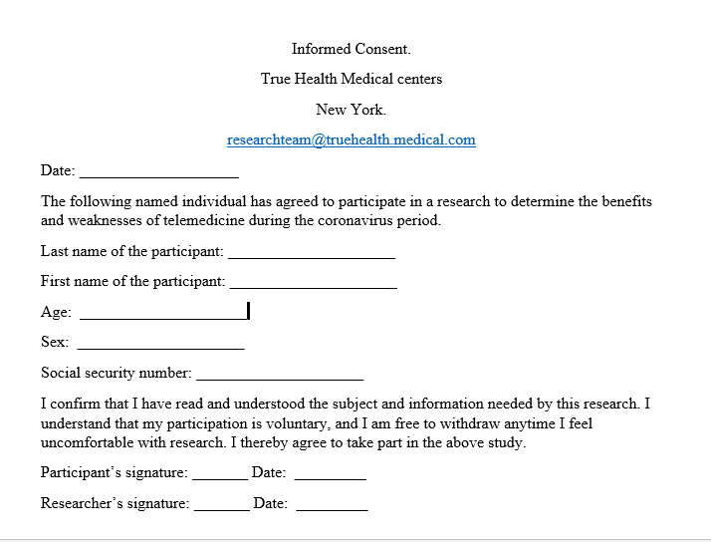
Methods of recruiting participants.
Finding the right demographic for research can be a complicated task. Researchers usually recruit participants using fliers, advertisements, letters, emails, and newspapers. Based on research by (Largent et al, 2017), some researchers often offer payment as an incentive to recruit participants into their research. Therefore, for this research, an advertisement for participating patients will be made through hospital newsletters and through email subscriptions for those patients that have a subscription. For the medical practitioners, recruiting will be done through fliers posted throughout the institution. The questionnaires will be distributed through work emails to all the medical practitioners of True Health Medical centers, and the patients will receive the questionnaire through the monthly newsletter from the hospital.
Quantitative data collection.
Quantitative data refers to the numerical data that has been collected and analyzed for the purpose of describing, predicting, or controlling variables of interest. Quantitative data assumes a fixed or measurable reality that has been collected by measuring things (Noyes et al, 2019). For this research, I will collect quantitative data such as age, participants address, no satisfied patients with the telemedicine services, no dissatisfied patients with the telemedicine services, no equipment dedicated for telemedicine services, and the amount of information regarding telemedicine on the hospital's servers.
Conclusion.
In summary, implementation of a design in research requires understanding effective methods of data collection, recruiting participants, and ensuring that the research is conducted ethically. Moreover, it is important to collect both qualitative and quantitative data to ensure that important details are collected to attain the best results from the research.

Reference.
Alonge, O., Rodriguez, D. C., Brandes, N., Geng, E., Reveiz, L., & Peters, D. H. (2019). How is implementation research applied to advance health in low-income and middle-income countries?. BMJ Global Health, 4(2), e001257.
Largent, E. A., & Lynch, H. F. (2017). Paying research participants: regulatory uncertainty, conceptual confusion, and a path forward. Yale journal of health policy, law, and ethics, 17(1), 61.
Noyes, J., Booth, A., Moore, G., Flemming, K., Tunçalp, Ö., & Shakibazadeh, E. (2019). Synthesizing quantitative and qualitative evidence to inform guidelines on complex interventions: clarifying the purposes, designs, and outlining some methods. BMJ global health, 4(Suppl 1), e000893.
Yip, C., Han, N. L. R., & Sng, B. L. (2016). Legal and ethical issues in research. Indian journal of anesthesia, 60(9), 684.

